Cry Wolf Classic
6-6-6 Format
September 9th, 2023 12:00PM Tee Time Start
$10/player for event, $10/player skin game, additional green & cart fees apply
5th annual Cry Wolf Classic featuring former drummer Paul Cancilla. When it comers to playing the drums Paul is on fire!
Format
Twosome partners
6.9 index and lower play Blue Tees
7.0 index and higher play White Tees
Ladies play Red Tees
Seniors 60 plus play Gold Tees
Hole’s # 1 - 6 – Best ball
Hole’s # 7 - 12 – Scramble
Hole’s # 13 -18 – Alternate shot
Paul Cancilla…then and now!
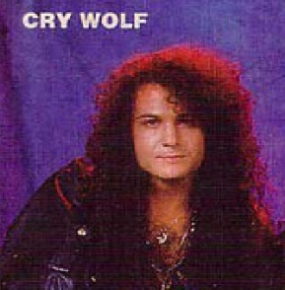

Team | Phone # | Email  (if not on record) | Handicap  Index

